Introduction

Within this coursework I will be setting out a plan for a piece of software of my chosen scenario, using the appropriate UML models as well as a series of entity relationship diagrams, both initial and normalised. I will also be coding a basic user interface in order to display a large data set appropriately. All diagrams will be drawn in draw.IO as well as described/annotated.

My chosen scenario will be a design for the police department, to be used to scope out suspected criminal activity by looking into the suspected perps social media message and friend connections.

GIThub Link

<https://github.com/La-Ola/ISAD157>

Requirements

Functional requirement for this application include:

* Storing users names
* Storing user IDs
* Storing users friends
* Store messages
* Store workplace
* Store school
* Allow users to interact with data- interface

Non-functional requirements:

* Legal
  + Security using a hashing table
  + GDPR – consent to store data
* Ethical
  + Storing peoples data long term
  + Viewing people data
* Usability; interface must conform to user accessibility rules

User stories

* As a police officer I want to enter a userID number and be displayed all their messages so that I can look for potentially incriminating evidence of a perp.
* As a police officer I want to enter a userID and be shown their last place of work/education so that I can follow leads.
* As a police officer I want to enter a userID and be shown their friends ID and names so that I can see if the are friends with other perps.
* As a police officer I want to be able to search through a user’s friends so that I can quickly see if there are associations between perps.
* As a police officer I want to enter a userID and be shown the gender of the perp so that I can match witness statements.

Use Case Diagrams

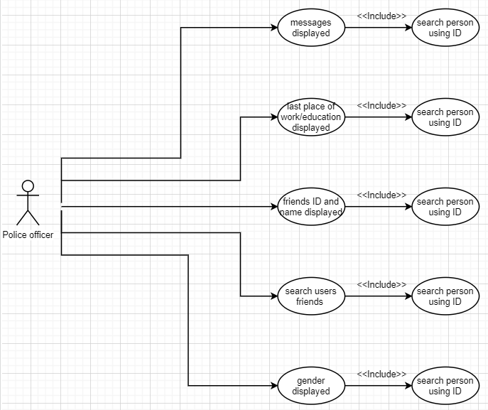

This use case diagram easily displays the different aspects of the software that the actor can explore; whilst showing the client what the developer grasps as most important functions to include.

Class Diagram

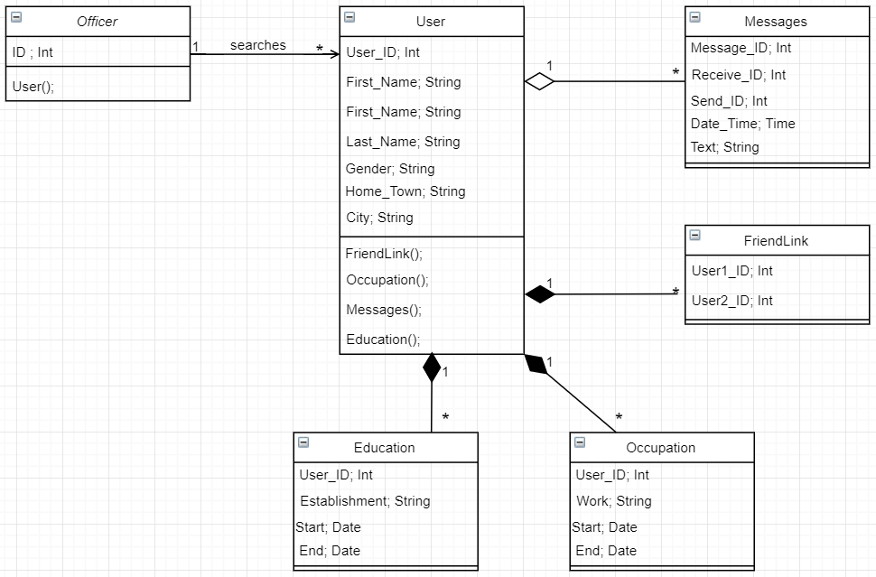

The class diagram is used to represent the static view of an application. It’s a strong and effective way to structure classes so that they can be translated in to an object orientated languages. It’s also a brilliant way to show the client how their data links together, giving them a higher understanding of their software. It uses both aggregation and composition arrows to convey the dependency on the main class ‘user’.

Activity Diagram of information retrieval

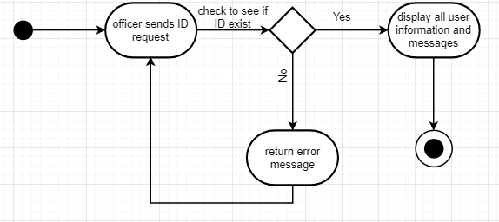

I have used an activity diagram to display the flow of information through the application to be made. The diagram moves from the start terminal to the first an action, which is an input from the user. Is then runs through a condition check, allowing the system to come to a termination.

Sequence diagram

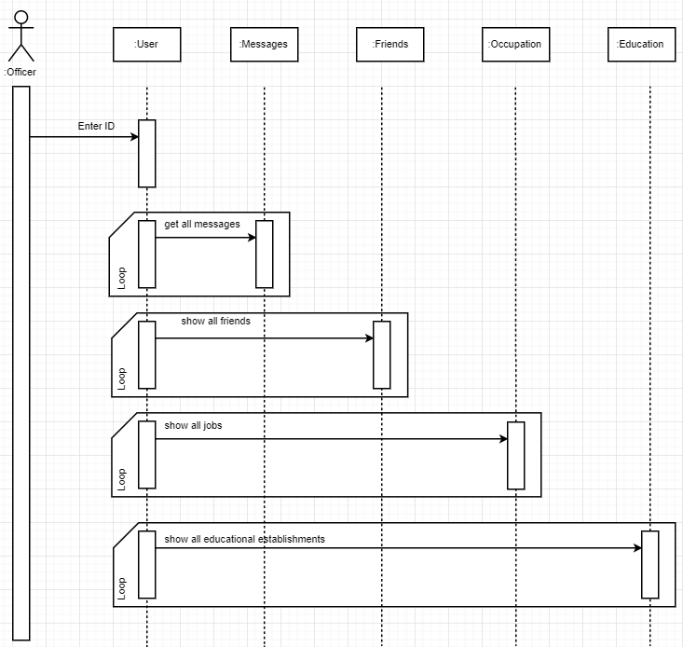

A sequence diagram is key to laying out the order of operations within a system. As the diagram descends the time of program execution is increasing; therefore, the first command will be made by the actor, Officer, by inputting the ID of the user they wish to search. After doing this, 4 loops are executed to claim information about the specific user.

State diagram

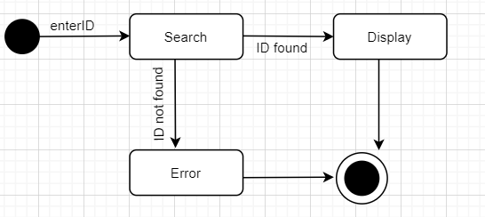

The state diagram is used to emphasise the states in which objects pass through. It is also used to match the systems states to real life states. The comments on each arrow indicate actions, they are used as transition commands between states.

UNF

User

User_ID

First_Name

Last_Name

Occupation

Education

Gender

HomeTown

City

Frienships

User_ID

First_Name

Last_Name

Messages

Sender_ID

Receiver_ID

Date/Time

Text

The UNF diagram

1NF

User

User_ID

First_Name

Last_Name

Gender

HomeTown

City

Frienships

User_ID

First_Name

Last_Name

Messages

Sender_ID

Receiver_ID

Date/Time

Text

Occupation

User_ID

Work

Starting

Ending

Education

User_ID

Establishment

Starting

Ending

2NF

User

User_ID

First_Name

Last_Name

Gender

HomeTown

City

Frienships

User_ID

First_Name

Last_Name

Messages

Message_ID

Sender_ID

Receiver_ID

Date/Time

Text

Occupation

User_ID

Workhaha

Starting

Ending

Education

User_ID

Establishment

Starting

Ending

3NF

User

User_ID

First_Name

Last_Name

Gender

HomeTown

City

Frienships

User1_ID

User2_ID

Messages

Message_ID

Sender_ID

Receiver_ID

Date/Time

Text

Occupation

User_ID

Job_Title

Starting

Ending

Education

User_ID

Establishment

Starting

Ending